
Penetration Testing Assignment: Zero Bank Web Application
Security Testing and Risk Analysis of Zero Bank Application

1. Executive Summary – Overview of Assessment Results
The purpose of this assessment was to evaluate the security posture of the target website zero.webappsecurity.com. Through network reconnaissance, automated scanning, and manual testing, the web application’s security controls and potential risks were analyzed. Server configuration and services were examined using Nmap and Nikto scans, while application-level testing was performed using OWASP ZAP and Burp Suite. Overall, the results showed that the application has implemented some important security headers; however, certain misconfigurations and access control–related issues were observed that require further assessment and mitigation.

2. Testing Methodology – Scope, Tools, and Approach

STEP 1: Network Reconnaissance (Nmap)

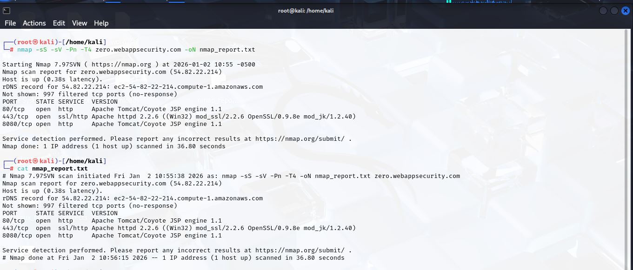
IN this phase using the nmap perform the different scan on target website. Firstly use the tcp syn scan to check on target website tcp port is open in the result analyze the port http and https is open which confirm the web service is the open then perform the service detection scan which confirm the website host at the apache web server and the end icm scan perform if the scan is block ho then complete the scan from the scan complete withotut any distrubance. Timing template is use to fast the speed of the scan and the result is accurate.
The majority of ports were filtered which is indicating the firwall protection. The presence of multiple web service and outdated software versions could present potential risks and were selected for further assesment.

STEP 2: Vulnerability Scanning (Nikto)

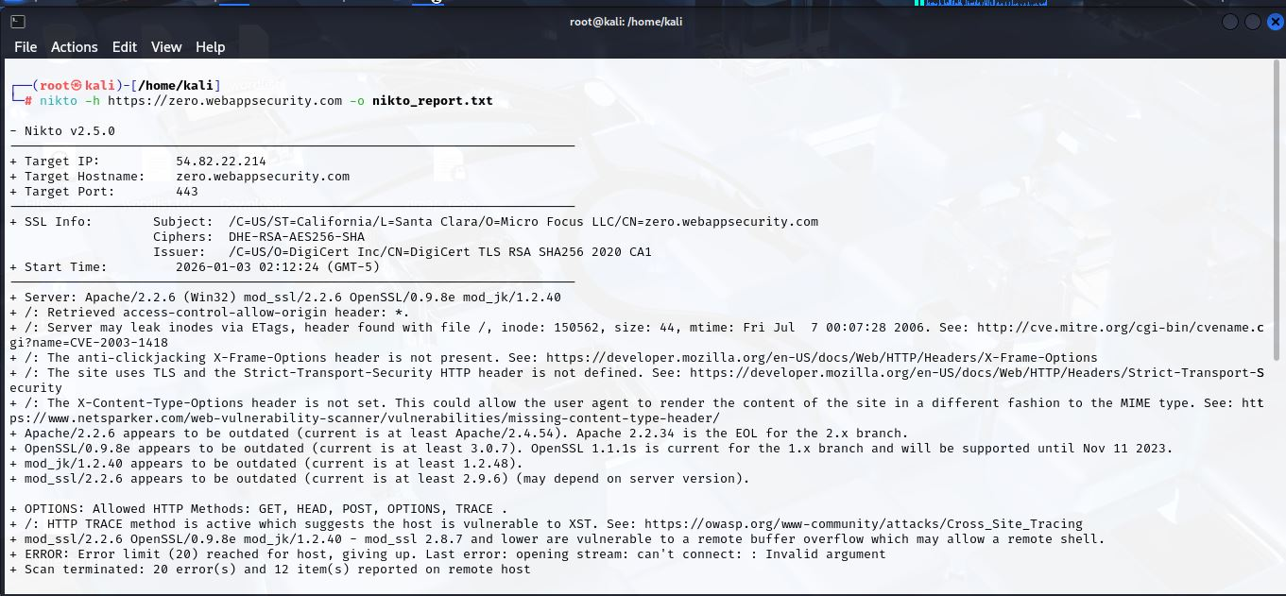
Nikto server scan the multiple security misconfigration and outdated software componet identify. Missing security headers, outdated Apache and open ssl version and through http trace method security risk in the web application. Fix this issue to improve the security of application.

STEP 3: Web Application Analysis (OWASP ZAP & HTTP Headers)

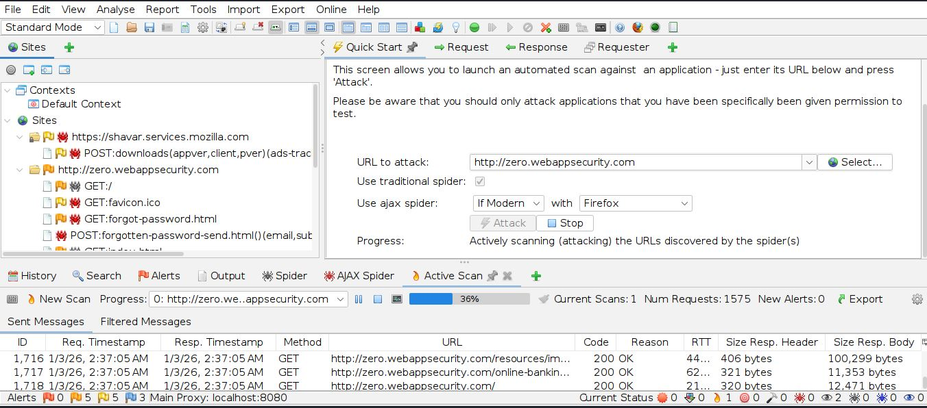

In ths scan analysis the high security risk is 0 and medium and low security risk are equal which indicated the missing of the security headers.
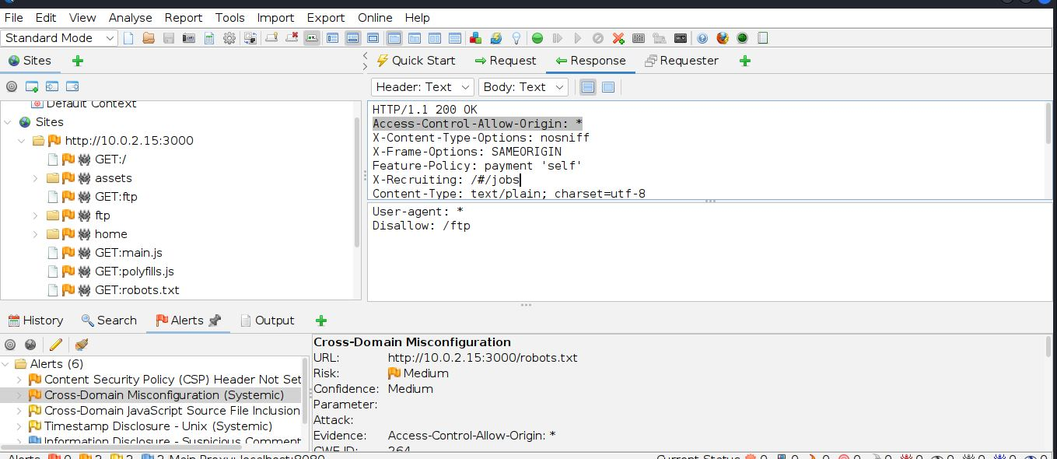
Server is implemnet the important security headers like options and X-frame options which is good for security but cors allow all origions which create the potential risk if the sensitive information is expose.
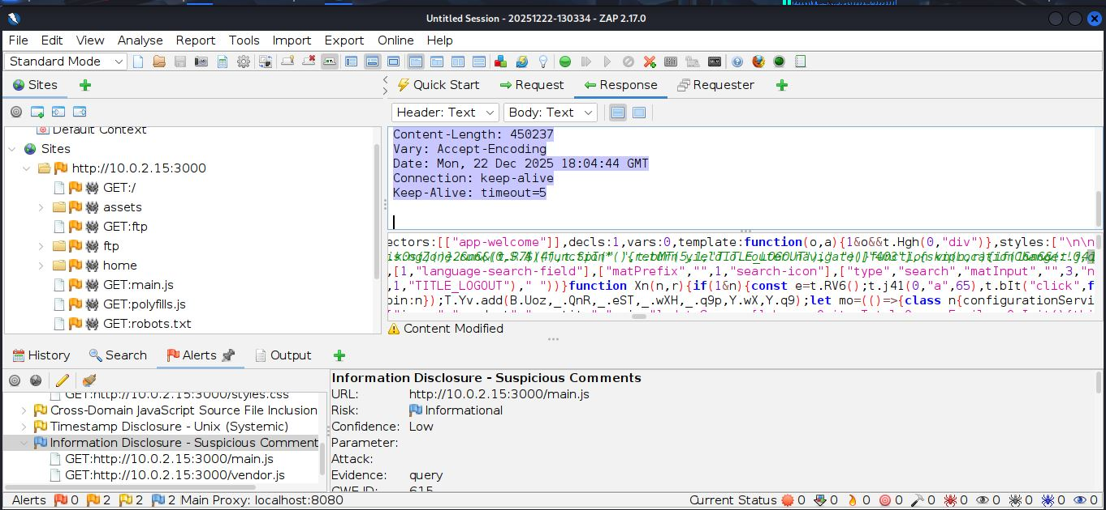
Target web application ka server response HTTP/1.1 200 OK ke sath mila. Response headers mein kuch security, caching aur performance related information thi. Access-Control-Allow-Origin: * header indicate karta hai ke resource ko koi bhi domain access kar sakta hai, jo sensitive data ke liye potential risk ho sakta hai. X-Content-Type-Options: nosniff aur X-Frame-Options: SAMEORIGIN headers implement hone ki wajah se MIME-type sniffing aur clickjacking se protection mil rahi hai. Feature-Policy: payment 'self' browser features ko sirf apni site tak restrict karta hai. Baaki headers jaise Cache-Control, Last-Modified, ETag, Content-Type aur Keep-Alive server ke performance aur caching ke liye use ho rahe hain. X-Recruiting aik custom header hai aur informational purpose ke liye hai. Overall, server ne kuch achay security measures implement kiye hain, lekin CORS policy ka * hona sensitive resources ke liye potential security risk create kar sakta hai.

3. Identified Vulnerabilities – Tabular Presentation o fPresentation of Findings
Vulerability | Observation
Missing security headers | Medium and low security alert risk detected
Cors misconfiguration | Access control,Allow region set to *
Outdated software | Apache and open ssl version
Access control | Unauthorized access show the sql error
Sql injection | Not detected
Xss | Not detected
Session handling | Not applicaple due to not login

4. Proof of Concept (PoC) – Technical Explanation with Evidence

STEP 4: SQL Injection Testing

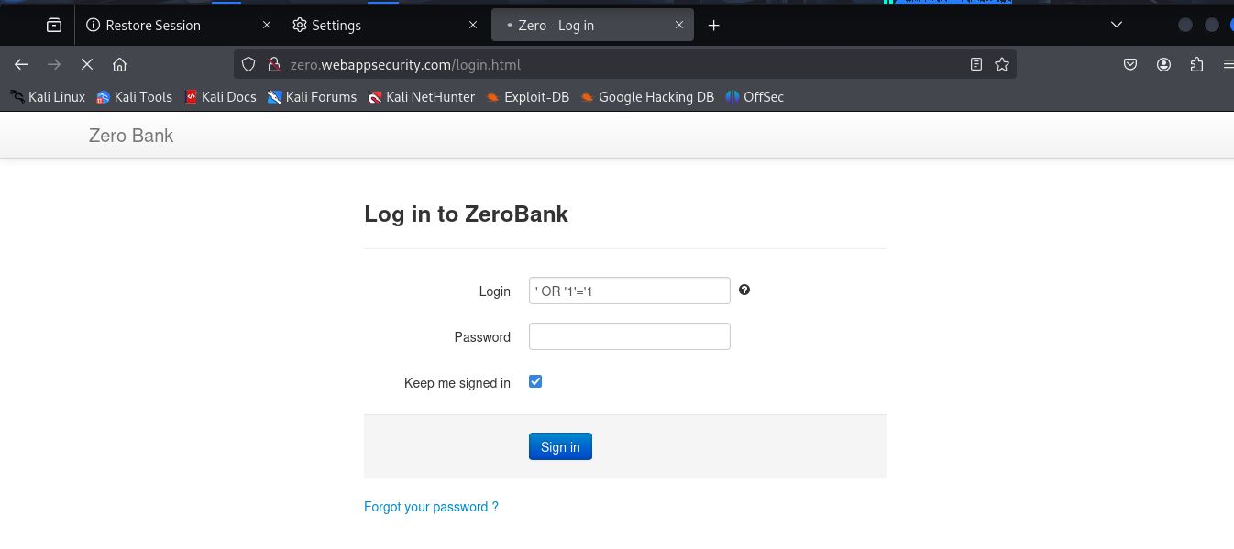
Burp Suite tool ka use karke target website zero.webappsecurity.com par manual testing perform ki gayi. Browser ko Burp Suite ke proxy ke sath configure kiya gaya taake HTTP/HTTPS requests aur responses capture kiye ja saken. Testing ke liye login page aur input fields ko access kiya gaya. SQL Injection testing ke dauran login form ke input field mein common SQL Injection payload ' OR '1'='1 submit kiya gaya. Is test ka maqsad yeh verify karna tha ke application unauthorized access allow karti hai ya nahi. Testing ke result ke mutabiq login bypass nahi hua aur koi database error message display nahi hua. Application ne normal response return kiya, jis se yeh confirm hota hai ke target website SQL Injection attacks ke against secure hai.

Cross-Site Scripting (Reflected & Stored)

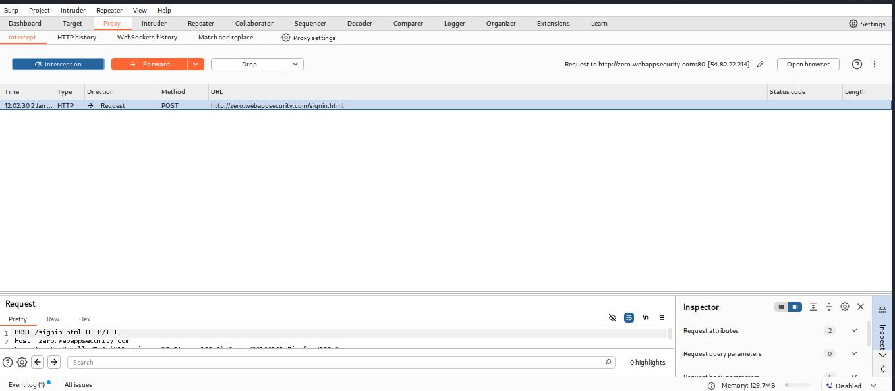
Cross site scripting perform on the username field. XSS payload submit but the script is not exeute website generate the wrong login attempt not any alert generate which is indicate the not any XSS vulnerability is here.

Session Handling Weakness

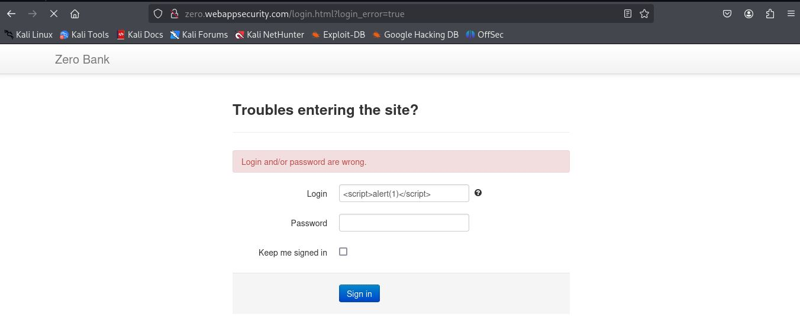
IN the target website not provide any user registration crenditials that’s why the authenticaton not succesful. Authentication session is not establish. I have tried to session handling but without successful login not possible that why not any session handling vulnerability find.

Access Control Testing

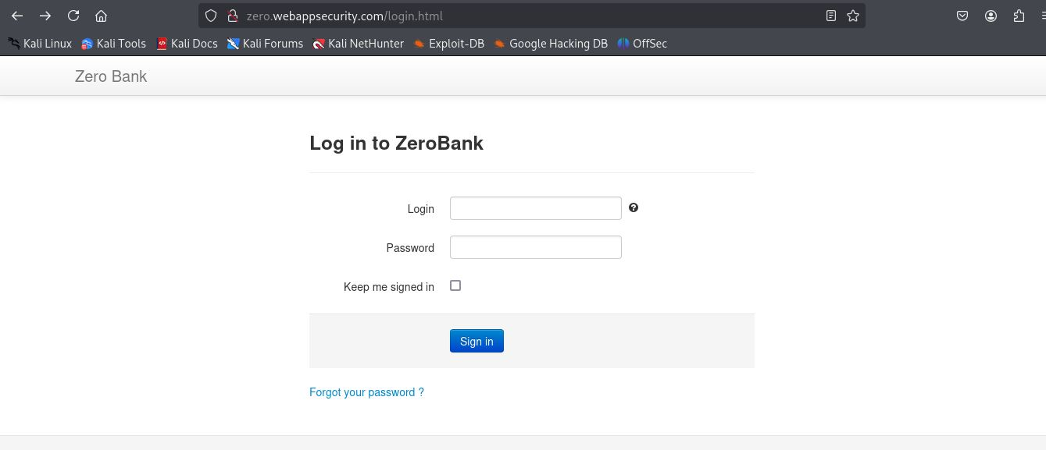
Acess control access testing perform through the direct url access for the unauthorized use the protected endpoint /account/summary. Application not redirect the sign in page and exectue the bakend database and display the sql query error. This behaviour indicate the improper access control.

5. Conclusion & Recommendations – Risk Mitigation Guidance
Overall assessment concludes that the target web application has implemented some important security controls such as x-frame-options and x-content-type-options, which are positive security practices. However, issues such as cors misconfiguration, missing security headers, and improper access control create potential risks for the application. To fix these issues, proper access control checks, a restricted cors policy, and updated server components are recommended in order to improve the overall security posture.

6. Appendices & Logs – Supporting Files and Exported Data
- Nmap Scan Report
- Nikto Scan Report
- OWASP ZAP Scan Report
- Burp Suite captured requests/responses

